Lab – Getting Started with GitHub using VS Code
To learn more about GitHub and code versioning go through the slides for understanding code versioning using GitHub
Installation of Git on your running machines
Step 1: To download and install git on your running machines, click here https://git-scm.com/downloads ,choose the right version – windows, macOS and linux. | 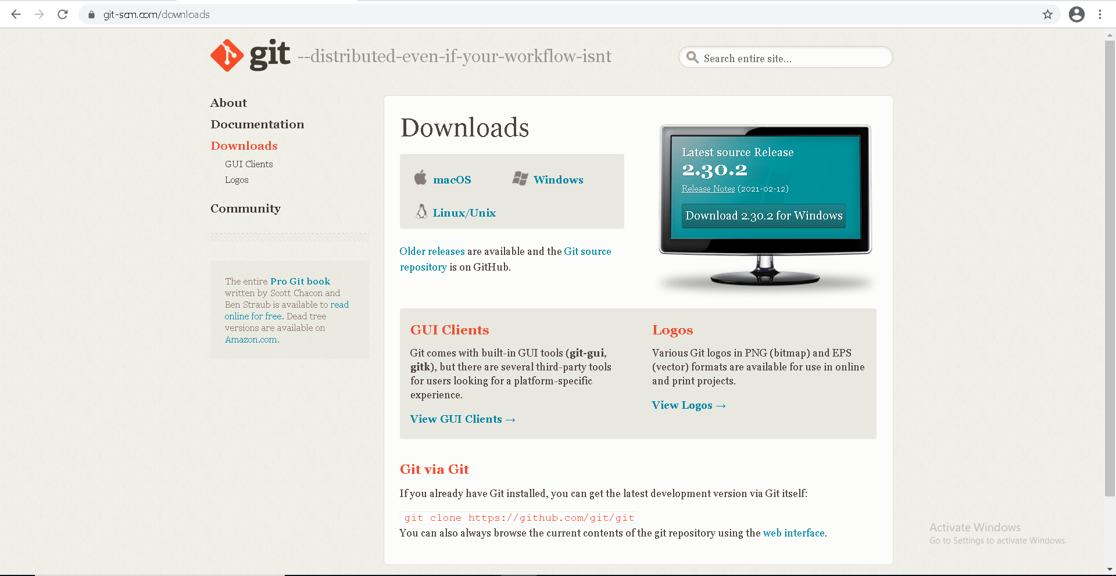
Step 2: Once it is downloaded open and start installation.  Click the next button until it asks for the editor you would like to use for git, you can choose any I prefer to choose “Use Visual Studio Code as Git’s default editor”. Hit the next button | 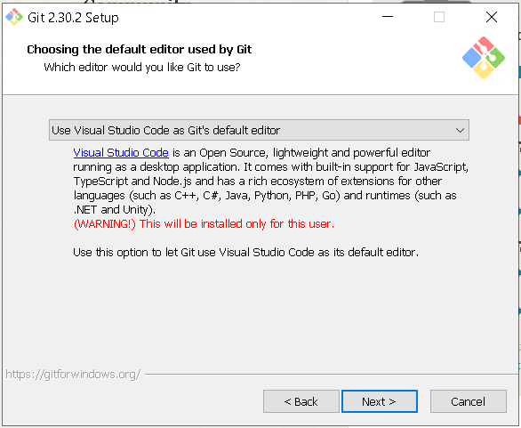
Step 3: hit the next button and let every setting for git be default as preselected. Once you get everything done, click install.
Step 4: once the installation is done click finish. | 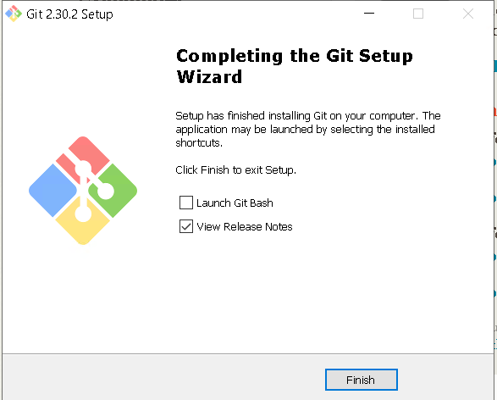
Now head over to GitHub.com and be sure to check out their help pages after signing up.
Once you are signed up create a new repository and name it PowerShell_Script as we are using it for our first PowerShell script we made. Make the repository public and hit create repository. | 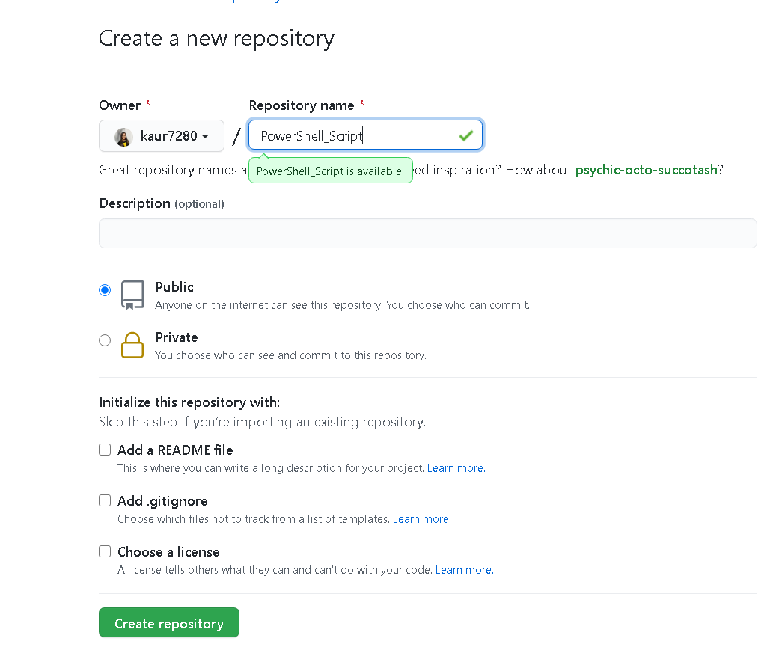
Copy the link for your repository from here. | 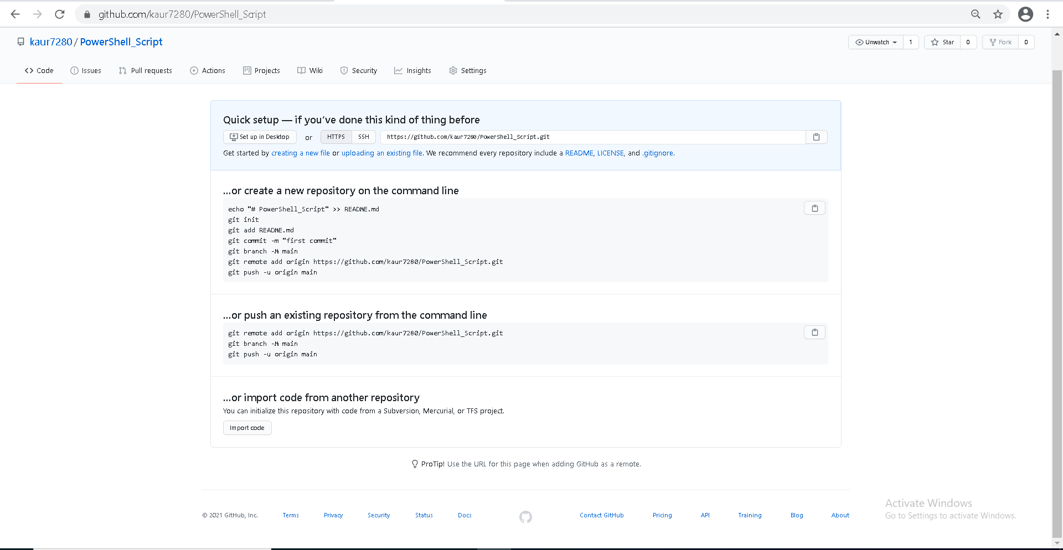
Open command prompt Run it as administrator. And type in  git config –global user.name “your username”  git config –global user.email your email  To set your username and email for GitHub. | $ git config --global user.name "John Doe"  $ git config --global user.email johndoe@example.com
Open VS Code, go to settings and type in git enabled check if the Git-Enabled check box is marked. | 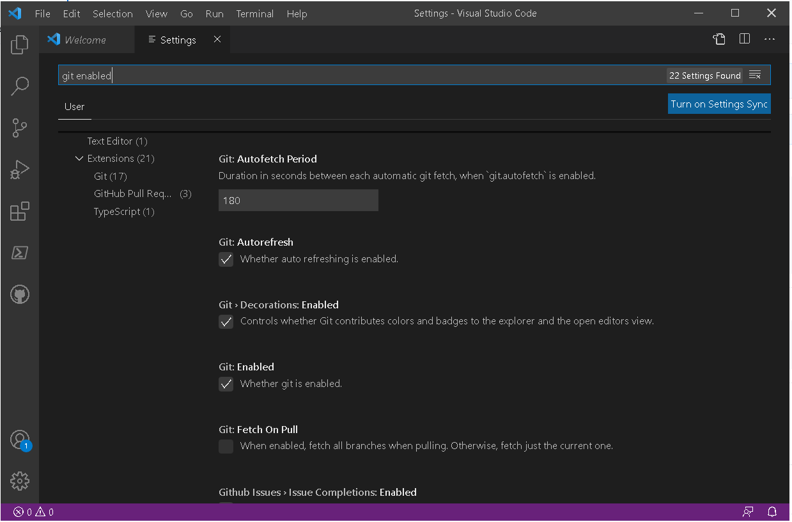
Add GitHub pull request and issues extension on your VS Code from extensions. Once its installed you can see the icon for GitHub in the activity bar. | 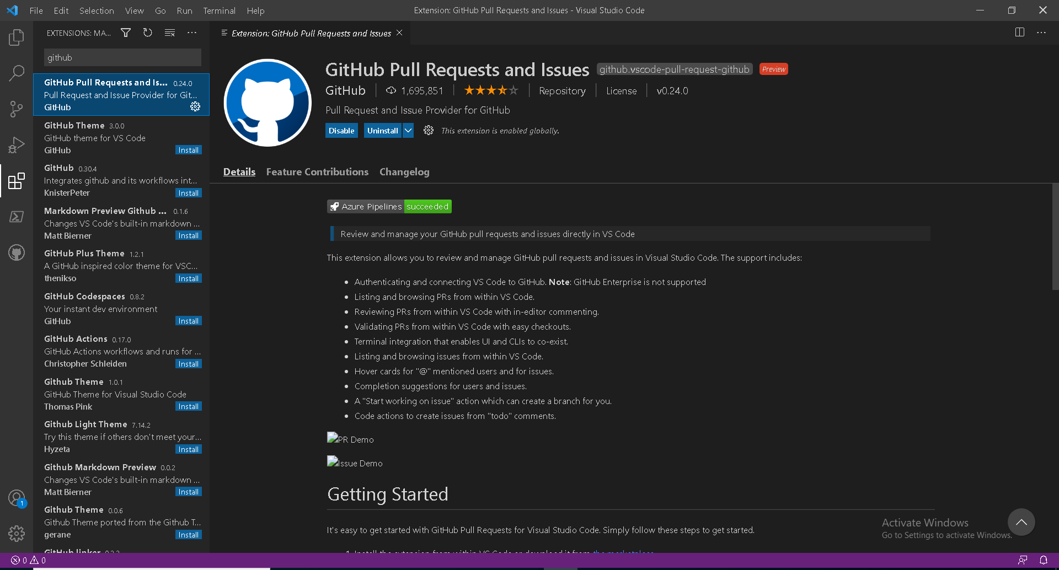
Go to the GitHub icon in activity bar and sign in with your GitHub account. Allow and continue to every confirmation warning and it will open your repository. | 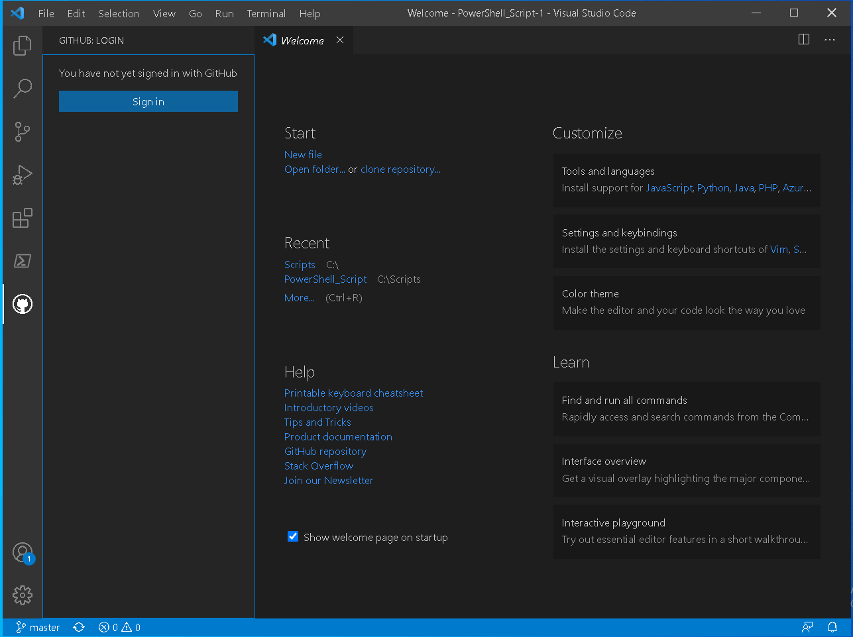
Click on file and open the folder in which our MyFirstScript.ps1 is saved. Then click on the git icon in activity bar. | 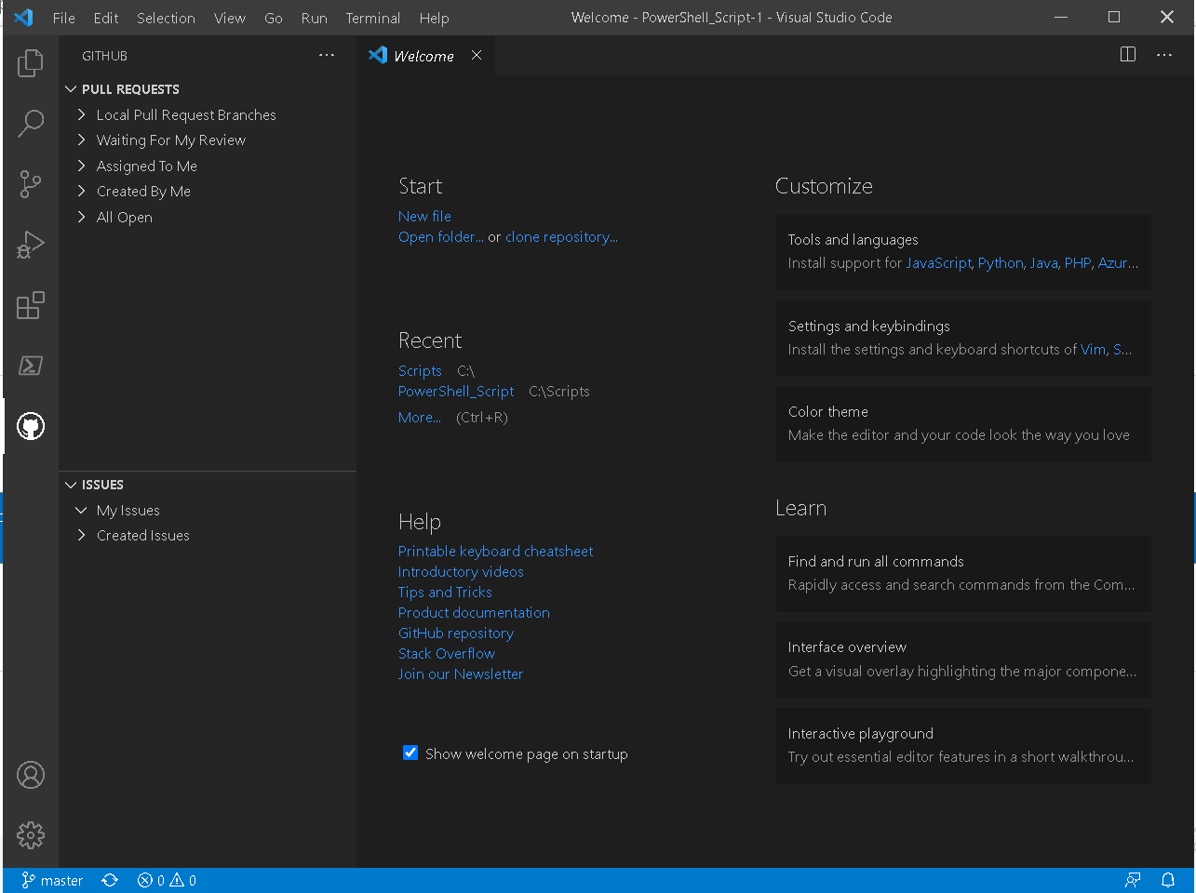
Collect all files that we want to push to GitHub and put them in one folder. And open that folder in VS Code. | 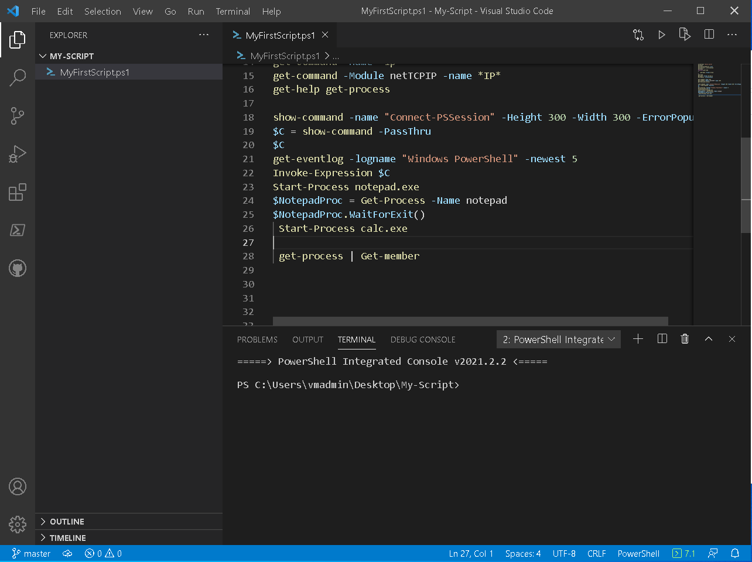
Open VS code and expand source control. Click on initialise repository. | 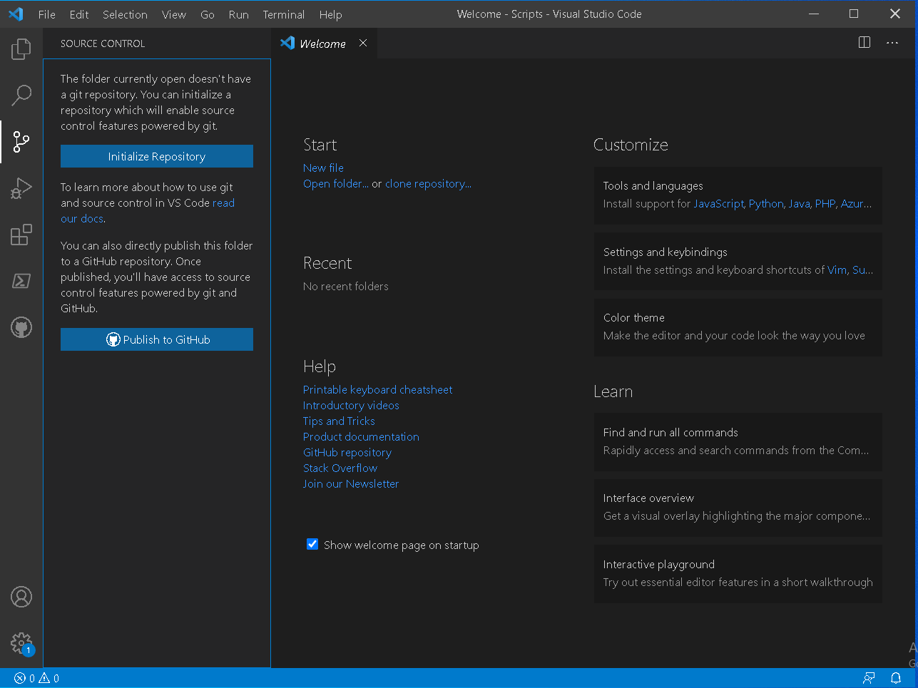
Source control will appear like this. | 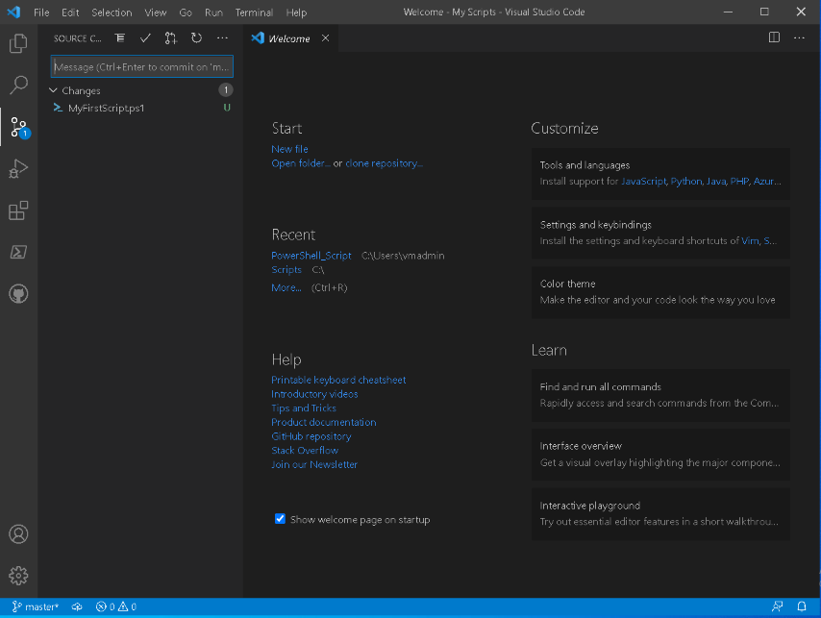
Write your commit message as “first-commit” and press Ctrl + Enter. It will ask you to open remote click yes. | 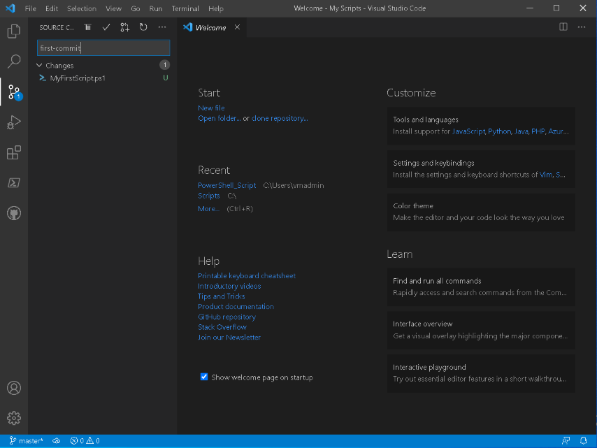
Click on the three dots, hover on pull, push and select “push to..”. | 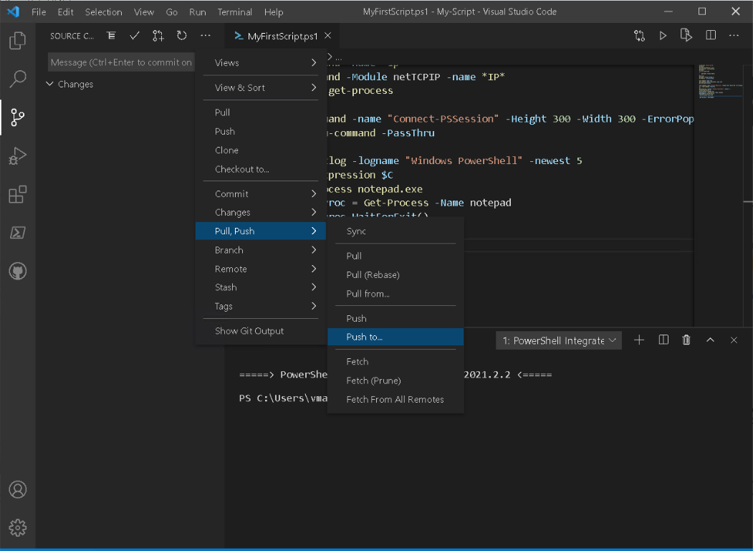
After selecting it will ask you to “pick a remote…” paste GitHub URL for our new repository here. | 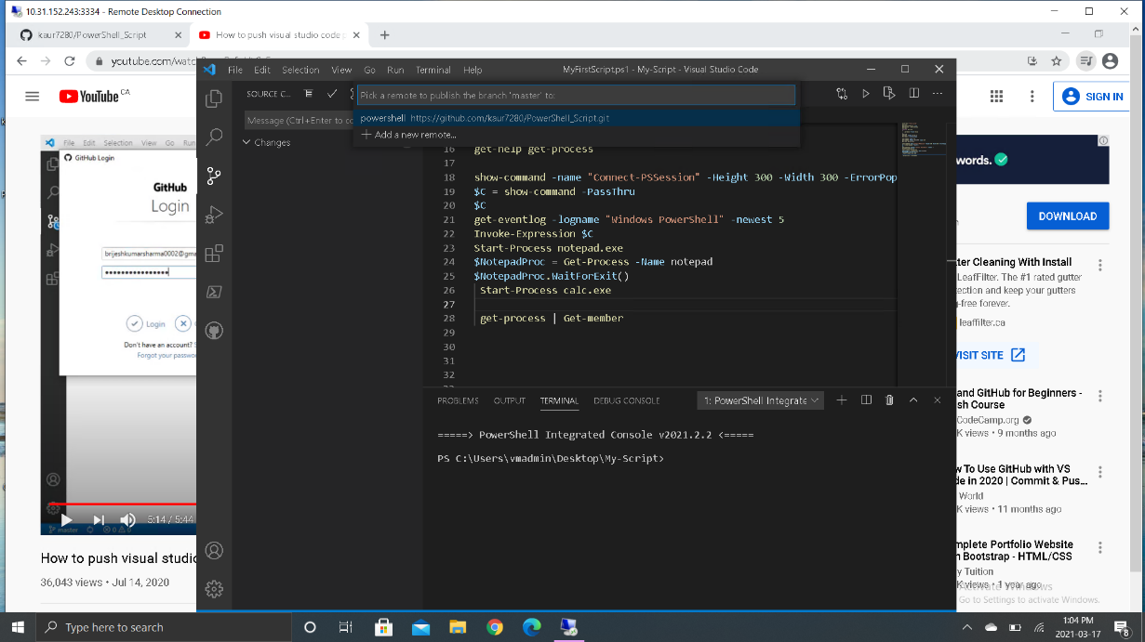
Then it will ask for a remote name, provide any and press enter. | 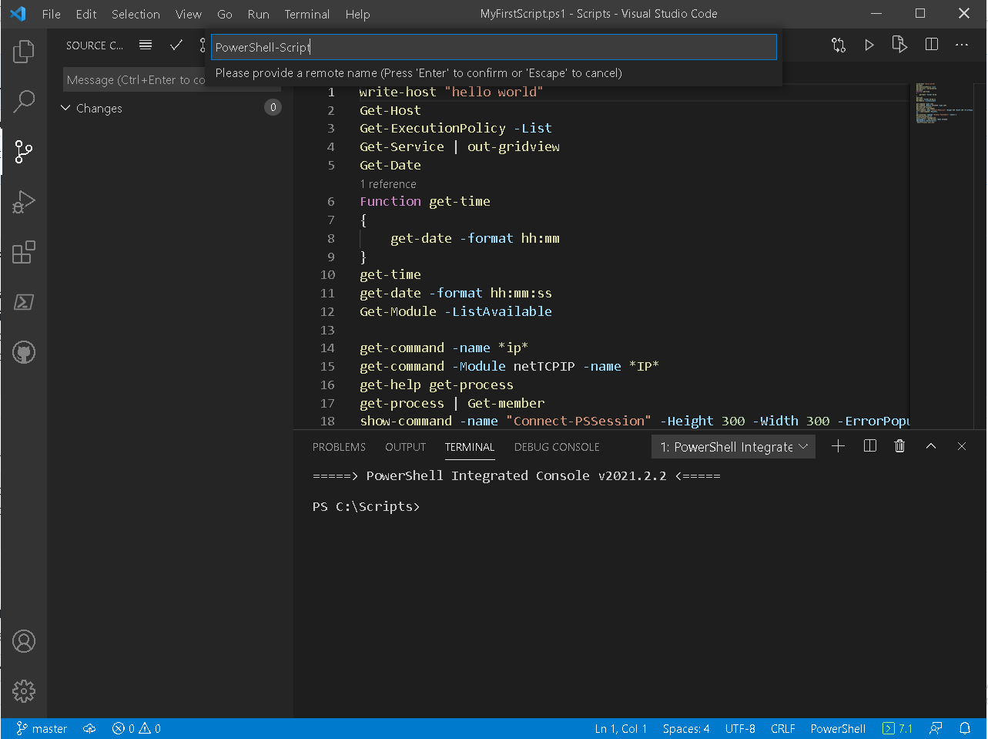
It will ask for sign-in to GitHub. Once you sign-in refresh your repository in browser and you can see your first commit, time for that commit, changes, and your code. | 